PHOENIX Database Schema Documentation
Revised May, 2026

Overview:
The PHOENIX database schema is designed to support an integrated system for analysing and managing natural hazards, cyber threats, and their combined risk during disaster events. The primary objective of this schema is to provide a structured, scalable, and consistent data foundation that enables backend processing, frontend visualisation, and AI/ML-driven risk assessment within the PHOENIX platform.
The schema is centred around three core entities: hazard events, cyber threats, and risk assessments. Hazard and threat data are collected from external sources such as weather services and threat intelligence feeds, then stored in a structured format to support efficient querying and analysis. The risk assessment component acts as a linking mechanism, integrating hazard and threat data to evaluate their combined impact and support decision-making processes.
To ensure flexibility and scalability, the schema follows a normalised relational design, using shared identifiers and foreign key relationships to maintain data integrity. Supporting tables such as GEO_LOCATION, EVENT_STATUS, and LINKED_EVENT_TYPE provide consistency and enable reusable data structures across the system. Additional reference tables are included to support time-based analysis and potential machine learning use cases.
The design also considers performance and future growth through indexing strategies, partitioning, and archiving plans. Furthermore, the schema is aligned with AI/ML requirements by incorporating consistent identifiers, timestamps, and structured relationships that facilitate data integration and advanced analytics.
Overall, this database schema establishes a robust and extensible foundation for the PHOENIX system, enabling effective integration of multi-domain data and supporting real-time insights during critical events.

Table Name
HAZARD_EVENT

Purpose
The hazard_event table stores structured information about natural hazard incidents collected from external data sources such as BoM. It serves as a core dataset for backend processing, risk assessment, and integration with AI/ML systems.

Primary Key
hazard_event_id (UUID)

Table Columns
hazard_event_id (UUID) – Unique identifier for each hazard event
url (TEXT) - ???
text (TEXT) - ???
timestamp (TIMESTAMPTZ) - ???
hazard_type (TEXT) – Type of hazard (e.g., flood, bushfire, storm)
hazard_severity (TEXT) – Severity classification (low, medium, high, critical)
hazard_timestamp (TIMESTAMPTZ) - ???
hazard_location (VARCHAR) - ???
hazard_status (VARCHAR) - ???
alert_level (VARCHAR) - ???
source (VARCHAR) - ???
event_status (TEXT) – Current state (active, resolved, monitoring)
start_time (TIMESTAMPTZ) – Time when hazard started
end_time (TIMESTAMPTZ) – Time when hazard ended (nullable)
source_id (UUID) – Reference to data source
source_ref_event (TEXT) – Original event ID from external source
description (TEXT) – Additional details of the event
created_at (TIMESTAMPTZ) – Record creation time
updated_at (TIMESTAMPTZ) – Last update time

Relationships
- hazard_event → risk_assessment (One-to-many)
- hazard_event → data_source (Many-to-one via source_id)
- hazard_event → hazard_location (one-to-many via hazard_event_id)

Constraints
- hazard_event_id is PRIMARY KEY
- source_id is FOREIGN KEY
- severity_level must be one of: low, medium, high, critical

Indexing Strategy
- Index on hazard_type
- Index on severity_level
- Index on start_time

Time-Based Query Support
The start_time and end_time fields support real-time monitoring, time-series analysis, and filtering by date.

Example Use Cases
- Retrieve high severity hazards in last 24 hours
- Display hazards on dashboard map
- Feed hazard data into AI models
- Link hazards with cyber threats for risk analysis

TABLE NAME
CYBER_THREAT

Purpose
The Threats table is designed to store information about potential or identified threats relevant to the PHOENIX system. These threats may originate from external intelligence sources, internal monitoring systems, or manual reporting.
The purpose of this table is to support the identification, classification, and tracking of threats so that they can be analysed and linked to risk assessments. This structure enables the system to monitor threat activity over time and support decision-making in risk management.

Column and Definitions
Column name | Data Type | Description
threat_id | UUID | Unique identifier for each threat record
threat_type | VARCHAR | The category or nature of the threat (e.g., cyber attack, infrastructure failure.)
source_id | UUID | Reference to the source providing the threat information.
title | VARCHAR | Short summary describing threat.
description | TEXT | Detailed explanation describing threat.
risk_level | VARCHAR (20) | Level of severity assigned to the threat
status | VARCHAR (20) | Current state of the threat (e.g., Active, Monitoring, Resolved.)
category | VARCHAR | General grouping of the threat (e.g., cyber, environmental.)
confidence_score | DECIMAL (5,2) | Level of confidence in the treat information.
detected_at | TIMESTAMPTZ | Date and time the threat was detected.
created_at | TIMESTAMPTZ | Date and time the record was created.
updated_at | TIMESTAMPTZ | Date and time the record was last updated

Primary Key:
threat_id
This field uniquely identifies each record in the threats table.

Foreign Keys:
source_id
References:
source.source_id
This relationship ensures that each threat is linked to a valid data source.

Constraints:
The following constraints are applied to maintain data integrity.
- threat_type must not be empty
- risk_level must contain one of the following values:
  - Low
  - Medium
  - High
  - Critical
- status must contain one of the following values:
  - Active
  - Monitoring
  - Resolved
  - Archived
- detected_at must contain a valid timestamp
These constraints help ensure consistent and reliable data storage.

Relationships to other tables
The threats table is connected to the risk assessments table through a foreign key relationship.
Relationship summary:
- One threat can be linked to multiple risk assessments.
- Each risk assessment references one specific threat.
This relationship allows the system to evaluate how individual threats contribute to overall risk levels.

Normalisation Explanation
The database schema is designed using standard normalisation principles to reduce redundancy and improve data consistency.
In this design:
- Threat information is stored in the Threats table
- Source information is stored separately in a Sources table
- Each record contains only data relevant to that entity
This structure supports maintainability, scalability, and efficient data management.

Indexing Strategy
Indexes are used to improve query performance and ensure efficient retrieval of threat data.
The following indexes are proposed:
- Index on threat_type
Used to quickly find threats by category
- Index on risk_level
Used to identify high-risk or critical threats
- Index on detected_at
Used to support time-based queries
- Composite index on status and detected_at
Used to efficiently retrieve active or recent threats
These indexes help optimise system performance when working with large datasets.

Query Optimisation Considerations
Threat data is expected to be queried frequently, particularly for:
- recent threats
- active threats
- high-risk threats
- threats from specific sources
To support these use cases, indexing and structured filtering conditions are implemented. This ensures that the system can respond efficiently to user requests and maintain acceptable performance levels.

Partitioning Plan
As the volume of threat data increases, the Threats table may be partitioned based on time.
Proposed Method
Partition by:
detected_at
This allows the database to store records in separate time-based segments, such as:
- monthly partitions
- yearly partitions
Time-based partitioning improves performance for recent data queries and simplifies the management of historical records.

Archiving Strategy
An archiving strategy is implemented to manage long-term data storage and maintain system performance.
Proposed Rule
Threat records may be moved to an archive table when:
- the threat status is Resolved or Archived
- the record is older than a defined retention period (e.g., 12 months)
Archived data remains available for reporting and auditing but does not impact the performance of the active system.

Security Considerations
Security is an important requirement for the PHOENIX database system.
The following security controls are recommended:
- role-based access control to restrict database access
- least privilege permissions for users
- regular database backups
- validation of incoming threat data
- logging of changes to threat records
These controls help protect sensitive information and ensure system reliability.

Example Use Cases
- Retrieve all high-severity cyber threats detected in the last 24 hours.
- Display active threats on the dashboard filtered by type, status, and time.
- Link a threat to one or more risk assessments during a disaster event.
- Provide structured threat records to AI/ML pipelines for correlation and scoring

TABLE NAME
RISK_ASSESSMENT

GOALS
RISK_ASSESSMENT connects hazard events and cyber threat events through shared keys, identifying when and under what circumstances a disaster or other emergency (hazard) is associated or being impacted by a cyber threat (threat).
This diagram describes the mental model this schema is representing:
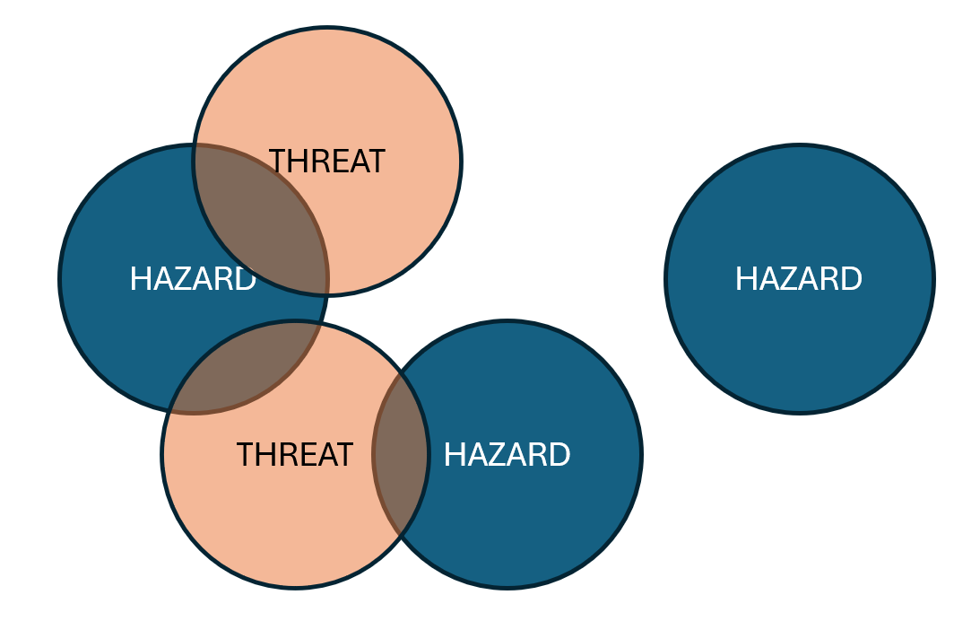
- Hazards are discrete
- Many threats can be relevant to each hazard
- A threat can be repeated across many hazards (for example, the same compromised domain may be deployed around different hazards) or a threat can span many hazards (a single misinformation social media post may include references to many different hazards). The schema articulates both of these scenarios.

DESCRIPTION OF TABLE CONTENT
Integration_event_id | UUID | PK identifier
related_hazard_event_id | UUID | FK linked to HAZARD table
related_threat_id | UUID | FK linked to THREAT table
correlation_score | REAL | Strength of relationship between linked events
linkage_reason | TEXT | Explanation of why events are linked
integration_confidence | REAL | Confidence that hazard and cyber events are connected
linked_event_type | INT | Defines whether record links hazard only, cyber only or both.  FK to LINKED_EVENT_TYPE table
event_status | INT | Current state of integrated event  FK to EVENT_STATUS table
event_time | TIMESTAMPTZ | Main time of occurrence used for integration
detected_at | TIMESTAMPTZ | Time at which linked event was detected
reported_at | TIMESTAMPTZ | Time at which linked event was reported
created_at | TIMESTAMPTZ | Record creation time
updated_at | TIMESTAMPTZ | Record update time

linked_event_type and event_status fields are keys linking to dimension tables in order to ensure consistency of field values.

TABLE NAME
INTEGRATION_LOG

GOALS
??

DESCRIPTION OF TABLE CONTENT
integration_event_id | UUID | PK identifier
integration_type | TEXT | ???
input | TEXT | ???
output | TEXT | ???
status | TEXT | ???
note | TEXT
created_at | TIMESTAMPTZ | Record creation time
updated_at | TIMESTAMPTZ | Record update time

TABLE NAME
LINKED_EVENT_TYPE

GOALS
LINKED_EVENT_TYPE is a dimension table that enumerates a short list of event type descriptions, used to ensure consistent descriptions in the RISK_ASSESSMENT table.
The EVENT_TYPE describes whether RISK_ASSESSMENT links hazard only, cyber only, or both.

DESCRIPTION OF TABLE CONTENT
linked_event_type_id | SERIAL | PK identifier
linked_event_type_description | VARCHAR | Defines whether record links hazard only, cyber only or both.

TABLE NAME
EVENT_STATUS

GOALS
EVENT_STATUS is a dimension table that enumerates a short list of integrated event status descriptions, used to ensure consistent descriptions in the RISK_ASSESSMENT table.
The EVENT_STATUS describes the stats of the integrated event or RISK_ASSESSMENT.

DESCRIPTION OF TABLE CONTENT
event_status_id | SERIAL | PK identifier
event_status_description | VARCHAR | Current state of integrated event

TABLE NAME
HAZARD_LOCATION

GOALS
HAZARD_LOCATION is a joining table that facilitates many-to-many links between hazards and their geolocation. A hazard many span multiple locations and in fact this is explicit in some of the weather data sources examined during discovery.
All rows in HAZARD_LOCATION are unique.

DESCRIPTION OF TABLE CONTENT
hazard_event_id | UUID | FK identifier
geo_location_id | UUID | FK identifier

TABLE NAME
THREAT_LOCATION

GOALS
THREAT_LOCATION is a joining table that facilitates many-to-many links between hazards and their geolocation. At time of writing threats are scoped to only be digital which by definition have no geo_location, however this table is provided so that:
- it can be adapted to locate digital threats to a geo_located source, for eg. Nigerian Prince scams;
- for future adaptability in the case that the project considers specifically geo_located threats such as a hacking attempt on a particular disaster recovery agency office system;
All rows in THREAT_LOCATION are unique.

DESCRIPTION OF TABLE CONTENT
threat_id | UUID | FK identifier
geo_location_id | UUID | FK identifier

TABLE NAME
GEO_LOCATION

GOALS
GEO_LOCATION is a dimension table that describes a particular geographic scope. Different data sources scope the location of hazards to different levels of precision, from a specific latitude and longitude point (eg. Grenfell Tower apartment building fire) to a state or country-wide natural disaster (eg. cyclones).

DESCRIPTION OF TABLE CONTENT
geo_location_id | UUID | FK identifier
country | VARCHAR | FK identifier
state_region | VARCHAR | State or region of event
local_government_area | VARCHAR | Local government area
suburb | VARCHAR | Local suburb or locality
latitude | DECIMAL | Latitude coordinate
longitude | DECIMAL | Longitude coordinate
geo_precision | VARCHAR | Location precision such as suburb, LGA, region

We note potential to further dimensionally model this table to ensure consistency of inputs (eg. suburb names), but at time of writing we propose that this be enforced as part of ETL logic in the ingestion pipeline rathe than cluttering the schema further.

TABLE NAME
SEASON

GOALS
SEASON is a dimension table that enumerates a short list of seasons of the year, used to ensure consistent descriptions in the REFERENCE_DAY table.

DESCRIPTION OF TABLE CONTENT
season_id | INT | PK identifier
season_description | VARCHAR | The season of the year

TABLE NAME
REFERENCE_DAY

GOALS
REFERENCE_DAY is an unlinked reference table that, in future, front-end systems or ML models may reference to describe relevant, additional characteristics of time-based data that may enhance the presentation or analysis of events.
The intention is for this table to describe additional characteristics consistently, but without the cost and vulnerabilities of fully dimensionally modelling a wide variety of date/time fields.

DESCRIPTION OF TABLE CONTENT
ref_date | DATE | A YYYY-MM-DD date
locale_id | INT | Identifies the regional locale of the date (eg. USA, Victoria)
dow | VARCHAR | Day of the week
is_weekend | BOOLEAN | TRUE if this day is a regular weekend day in the locale
season | INT | Season of the year.  FK to SEASON table
is_holiday | BOOLEAN | TRUE if this day is an official public holiday

ref_date and locale_id form a joint PK in this table. This facilitates describing different attributes of the same day in different places. For eg. King’s Birthday public holiday varies in different states; or some Islamic countries may take Friday as a weekend day.
This table may be manually pre=populated or updated from time to time, or it may be built progressively from original data sources as part of an ETL ingestion pipeline.

TABLE NAME
REFERENCE_TIME

GOALS
REFERENCE_TIME is an unlinked reference table that, in future, front-end systems or ML models may reference to describe relevant, additional characteristics of time-based data that may enhance the presentation or analysis of events.
The intention is for this table to describe additional characteristics consistently, but without the cost and vulnerabilities of fully dimensionally modelling a wide variety of date/time fields.

DESCRIPTION OF TABLE CONTENT
ref_time | TIME | A HH:MM time of day
is_nightime | BOOLEAN | TRUE if this time can be generally considered to be nighttime
is_business_hours | BOOLEAN | TRUE if this time can be generally considered to be during the main part of the active day

We recognise that attributes such as is_business_hours may vary across locales in the same way as dates in the REFERENCE_DAY table, but have omitted this idea in the REFERENCE_TIME table or simplicity as the differences are not critical.
This table may be manually pre=populated or updated from time to time, or it may be built progressively from original data sources as part of an ETL ingestion pipeline. The table may be populated with an exhaustive list of HH:MM across the day, or it may only include for eg. 24 individual hourly records that are referenced in a greater/ess than lookup when utilised.

TABLE NAME
USER_ACCOUNT

Purpose
The user_account table stores user logon information for the application.

Column and Definitions
Column name | Data Type | Description
user_id | UUID | Unique identifier for each user record
password_hashed | VARCHAR | Hashed user password
role | VARCHAR | Supports role based user access
access_token | VARCHAR | ???
refresh_token | VARCHAR | ???
username | VARCHAR | A unique username for each user to logon with
created_at | TIMESTAMPTZ | Date and time the record was created.
updated_at | TIMESTAMPTZ | Date and time the record was last updated

Primary Key:
user_id
This field uniquely identifies each record in the user_account table.

Foreign Keys:
none

Constraints:
The following constraints are applied to maintain data integrity.
- user_id must be unique
- user_name must be unique

Relationships to other tables
Nil

Table Name
DATA_SOURCE

Purpose
The data_source table stores information about ingested data sources as an audit function.

Primary Key
source_event_id (UUID)

Table Columns
source_name (VARCHAR) – Name of the data source (eg. “BOM”, “SES”)
source_type (VARCHAR) – Type of data source (eg. “Hazard”, “Threat”)
access_method (VARCHAR) – How the source is accessed (eg. “API”, “RSS”)
source_url (TEXT) – Source url (eg. API call)

Relationships
- source_id → data_ingestion_streaming_log (One-to-many)
- source_id → cyber_threat (one to one)

Constraints
- source_id is PRIMARY KEY

Indexing Strategy
- none

Notes
A link to hazard_event was removed in this revision (May 16), the source for hazards is now stored as a single text field in the hazard_event table.

TABLE NAME
DATA_INGESTION_STREAMING_LOG

Purpose
???

Column and Definitions
Column name | Data Type | Description
ingestion_log_id | UUID | Unique identifier for each record
source_id | UUID | FK
ingestion_type | VARCHAR | ???
payload | JSONB | ???
processing_status | VARCHAR | ???
fail_reason | TEXT | ???
received_at | TIMESTAMPTZ | ???
processed_at | TIMESTAMPTZ | ???
created_at | TIMESTAMPTZ | Date and time the record was created.
updated_at | TIMESTAMPTZ | Date and time the record was last updated

Primary Key:
ingestion_log_id
This field uniquely identifies each record in the table.

Foreign Keys:
source_id references data_source.source_id

Constraints:
The following constraints are applied to maintain data integrity.
- ingestion_log_id must be unique
- ingestion_type must be one of “hazard”, “cyber_threat”
- processing_status must be one of “received”, “processing”, “processed”, “failed”

Relationships to other tables
source_id references data_source.source_id

PHOENIX System – Database ER Diagram (Backend Structured Data Schema)
